Global Superstore Power BI Report

Executive Summary
This report presents a comprehensive analysis of sales, profit, customer behaviour, and delivery performance in the Global Superstore dataset. The analysis identifies key insights such as sales trends, top-selling product, and the most profitable customer segments. Delivery performance was assessed through average shipping times.
Several data issues were identified, including missing postal codes and negatives profit values in the Furniture Category. Based on the insights generated in Power BI, this report provides recommendations to improve profitability.

Objectives
The objective of this report is to answer the following questions:
- Identify sales and profit performance across regions, categories, and segments
- Understand customer behaviour such as order frequency and profit generated
- Evaluate delivery performance
- Identify the most and least profitable product
- Analyse shipping cost impact on profit

Data Overview
The details of the dataset used in this report are as follows:
- Dataset: Global Superstore
- Source: Kaggle
- Rows: 51,290
- Columns: 24
- Time Range: 2011-2014
- Key Fields: Order Date, Ship Date, Customer Id, Sales, Profit, Quantity, Category and Sub-Category

Data Preparation
Several data preparation done before the analysis are as follows:
- Checked for missing values
- Removed postal code column because of 80% missing values
- Removed unnecessary column (Row ID)
- Set correct data types for all columns (dates, numeric, region)
- Created date table
- Created relationship between Date table and Order table (active relationship on order date and inactive relationship on ship date)
- Created key measures

Key Measures
Key measures created with DAX include:
- Total Revenue
- Total Profit
- Profit Margin
- Total Orders
- Total Customers
- New Customers
- Total Products
- Average Delivery Days
- Average Spend per Customer
- Average Order Frequency
- Retention Rate
- On-Time Delivery Rate

Dashboard Pages

Page 1: Sales Overview
This page highlights overall sales overtime, across categories, and across countries
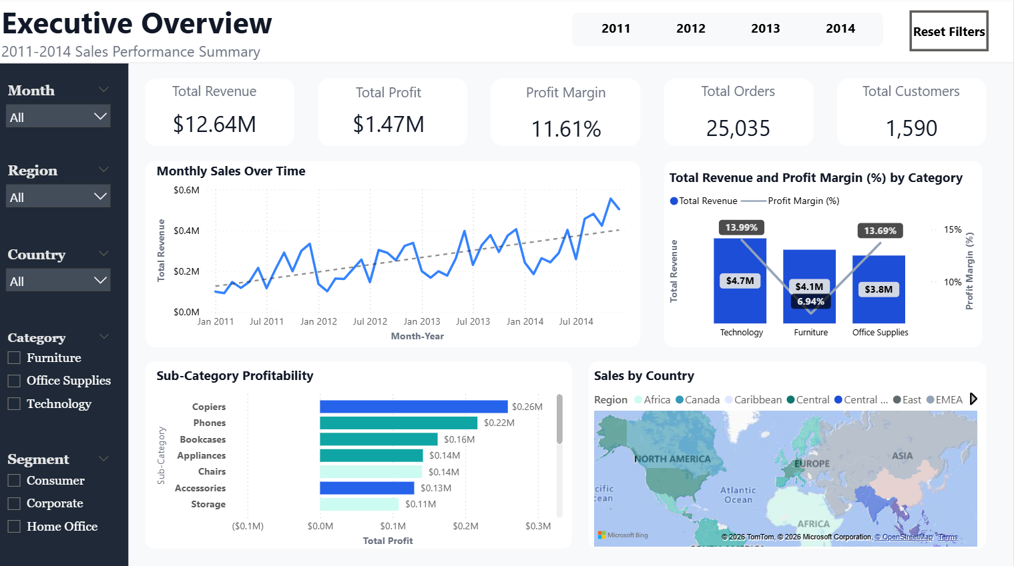

Key Visuals:
- KPI Cards: Total Sales, Total Profit, Profit Margin, Total Orders, Total Customers
Figure 1 KPI Card Visuals
- Line Chart: Monthly sales trend
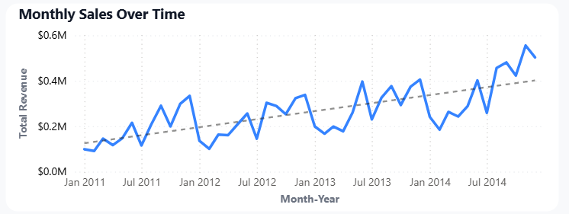
Figure 2 Monthly Sales Over Time

- Bar Chart: Sales by Category, Profit by Sub-Category
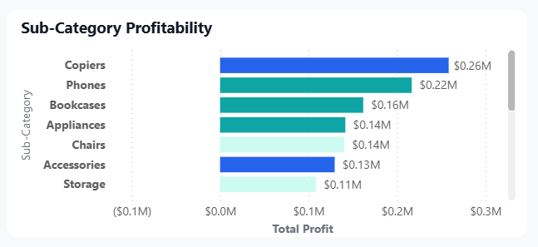
Figure 3 Profit by Sub-Category

- Map: Sales by Country
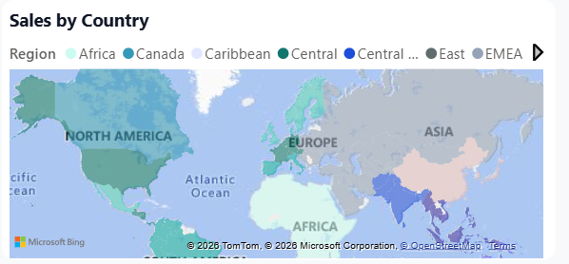
Figure 4 Sales by Country & Region

Insights to Mention:
- A seasonal sales trend, sales increased towards the end of year and dropped on January
- Technology category generated the most sales
- Most orders come from the USA

Page 2: Customer Analysis
This page highlights customer behaviour, including new customer every year, average spend per customer, and average order frequency.
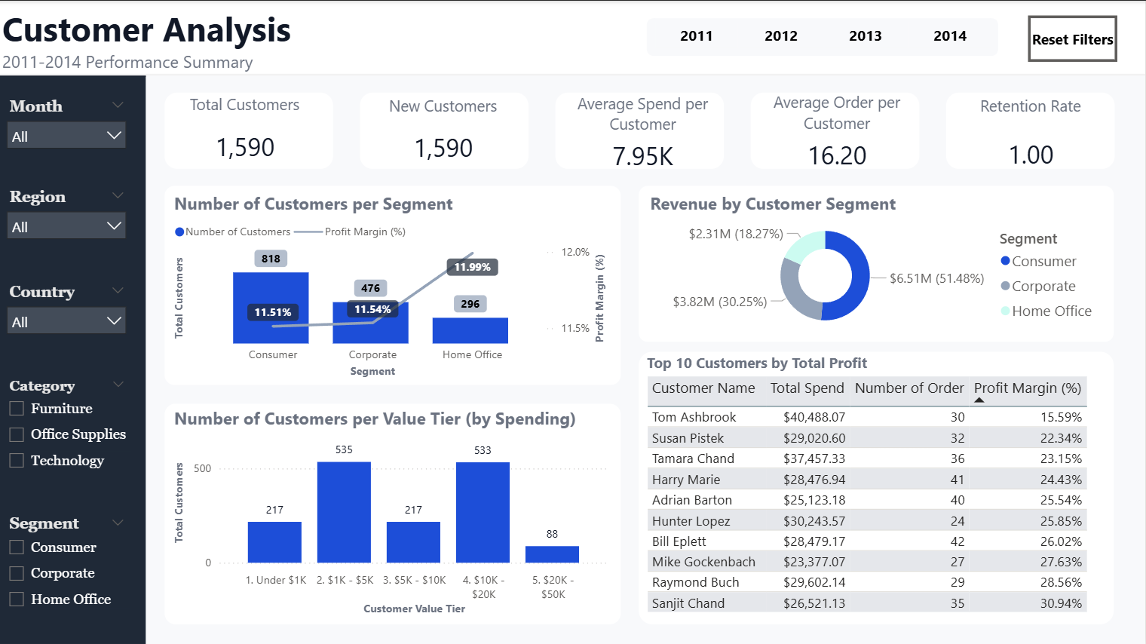

Key Visuals:
- KPI Cards: Total Customers New Customers, Average Spend per Customer, Average order Frequency, Retention Rate
Figure 5 Customer KPI Cards
- Combo Chart: Number of Customers per Segment
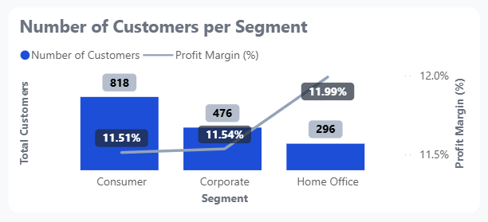
Figure 6 Number of customers per Segment

- Pie Chart: Revenue per Customer Segment
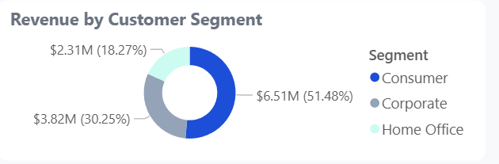
Figure 7 Customer Revenue per Segment
- Table: Top 10 Customers by Total Profit
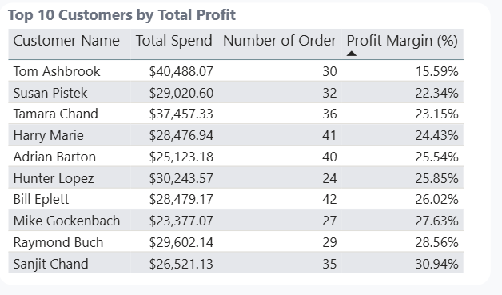
Figure 8 Top 10 Customers by Profit

Insights to Mention:
- Most customers are regular consumers
- Very few new customers each year with only 15 new customers in 2014
- Even with high order frequency, most of the orders generated low to no profit
- Home office being the most profitable customer segment with the lowest customer count

Page 3: Product Analysis
This page highlights product performance, including top selling products, most profitable products, and least profitable products across categories.
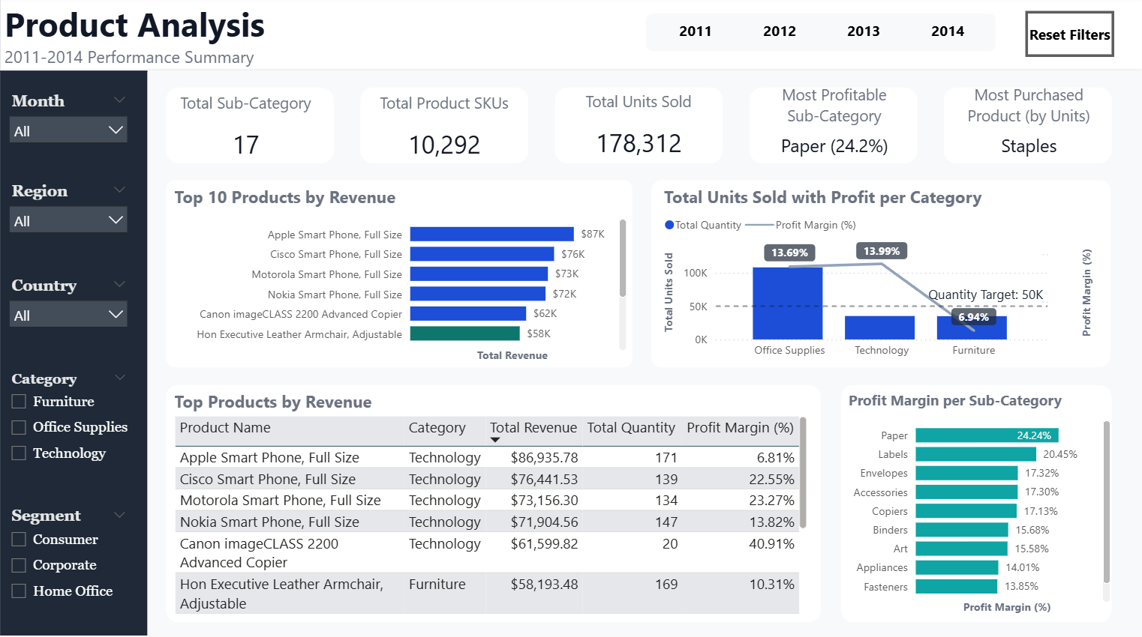

Key Visuals
- KPI Cards: Total sub-category, Total Product SKUs, Total Units Sold, Most Profitable Sub- category, Most Purchased Products (by Units)
Figure 9 Product KPI Cards

- Bar Chart: Top 10 Products by Revenue
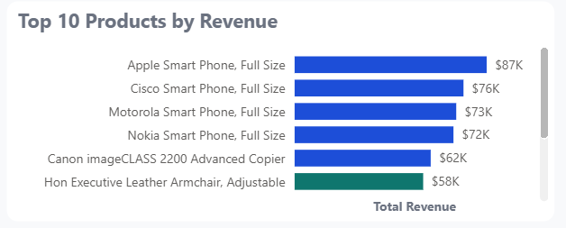
Figure 10 Top 10 Products by Revenue
- Combo Chart: Total Units Sold and Profit per Category
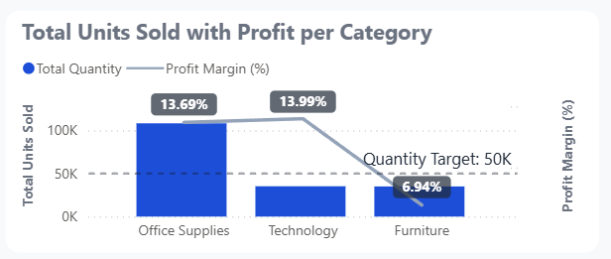
Figure 11 Total Units Sold per Category

- Table: Top Products by Revenue
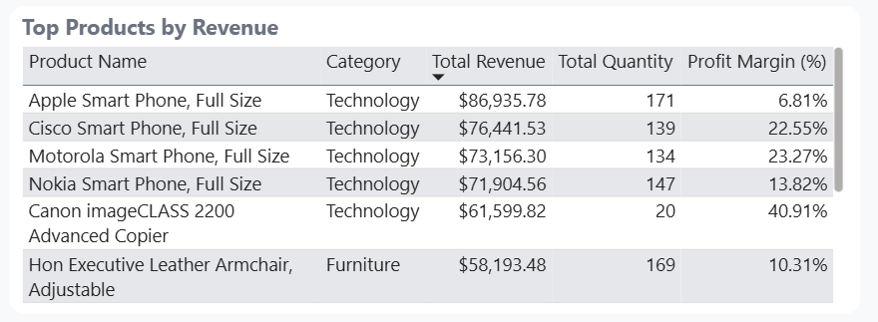
Figure 12 Top Products by Revenue

Insights to Mention
- Staples are the most purchased products by units
- Most profitable sub-category is paper with 24.2% margin
- Technology category has the highest profit margin
- Office supplies category has the most items sold
- Furniture category has the least number of items sold and the least profit with tables product having negative profit margin

Page 4: Shipping and Delivery
This page highlights shipping and delivery performance on different ship mode across country & region.
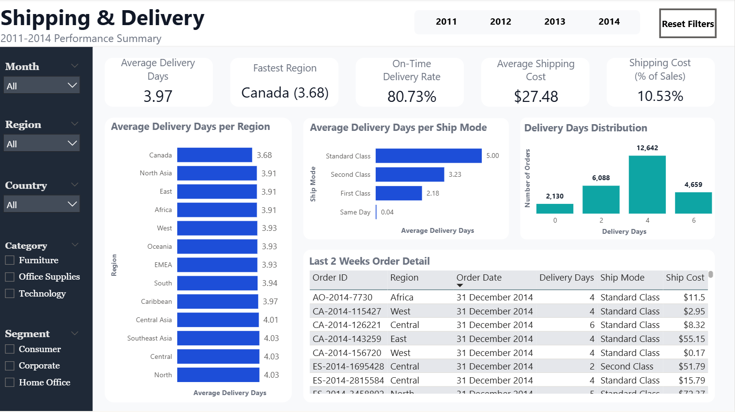

Key Visuals
- KPI Cards: Average Delivery Days, Fastest Region, On-Time Delivery Rate, Average Shipping Cost, Shipping Cost (% of Sales)
Figure 13 Product KPI Cards
- Bar Chart: Average Delivery Days per Region, Average Delivery Days per Ship Mode
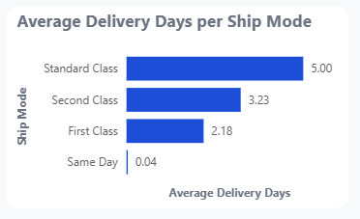
Figure 14 Average Delivery Days per Ship Mode
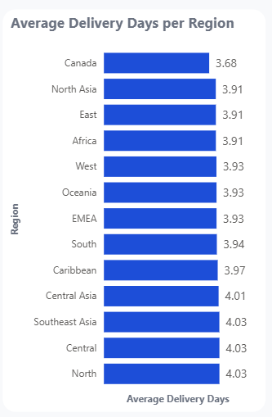
Figure 15 Average Delivery Days per Region
- Column Chart: Delivery Days Distribution
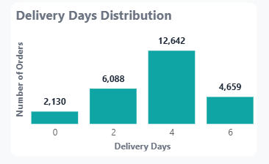
Figure 16 Delivery Days Distribution
- Table: Last 2 Weeks Order Details

Figure 17 Last 2 Weeks Order Details

Insights to Mention
- Overall average delivery days is 3.97
- Canada is the region with the lowest average delivery days
- On-time delivery rate (<= 5 Days) is 81%
- Shipping cost is around 11% of revenue
- Most delivery time are around 4-5 days

Recommendations
Based on the analysis conducted on Power BI, there are several recommendations for the company listed below.
- Focus marketing on customers with high order frequency but low profit generation and customers with high profit generation but low order frequency
- Focus on promoting high-margin technology items
- Optimise discount or costs for Furniture category (low-profit items)
- Optimise pricing strategies for unprofitable items.

Conclusion
This report provided an overview of sales, customer behaviour, and product profitability in the Global Superstore retail dataset. The report highlights key insights such as sales trend, customer order frequency, product popularity, and delivery times using interactive visualizations.
The findings show that while the total sales are relatively the same across product categories, profitability varies significantly across the product sub-categories, which shows that sales alone cannot be used as the indicator of performance. A seasonal trend is clearly shown on the visuals, providing insight into potential targeted marketing on holidays or high season.
Customer analysis with average order frequency and profit generation revealed patterns that can support marketing prioritization, for customer with low order frequency but high profitability and customer with high order frequency but low profitability. Operational analysis of delivery performance also provided additional insight into areas where the efficiency can be improved.

